4.Vaccum Cleaner

Aim
To implement the Vacuum Cleaner Problem using Python.

Objective
- To simulate the working of a vacuum cleaner.
- To clean all dirty rooms and reach the goal state.

Algorithm
- Start.
- Initialize two rooms as Dirty.
- Place the vacuum cleaner in the first room.
- If the room is Dirty, clean it.
- Move to the next room.
- Repeat until all rooms are checked.
- Display the final state.
- Stop.
Flow Chart:

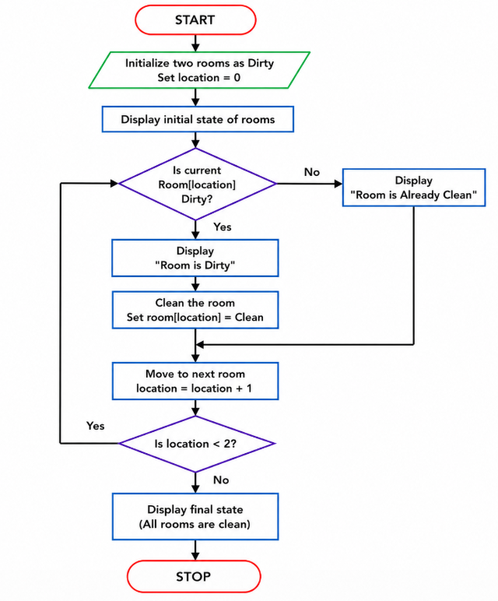

Coding:
room = ['Dirty', 'Dirty']
location = 0

while location < 2:
if room[location] == 'Dirty':
print("Room", location + 1, "is Dirty")
print("Cleaning Room", location + 1)
room[location] = 'Clean'
else:
print("Room", location + 1, "is Already Clean")

location += 1

print ("\nFinal State:")
print ("Room 1:", room[0])
print ("Room 2:", room[1])
print ("All rooms are clean.")

Output:
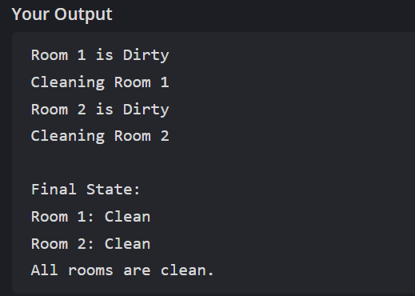

Result:
Thus, the Vacuum Cleaner Problem was implemented successfully, and all the rooms were cleaned.

